Q1 | Download a sample CSV file of IPL cricket match scores from Kaggle or any public dataset, and use pd.read_csv() to load it into a DataFrame. Print the first 5 rows to verify the data.
Code | import pandas as pd  df = pd.read_csv("matches.csv")  print(df.head(5))
Output | 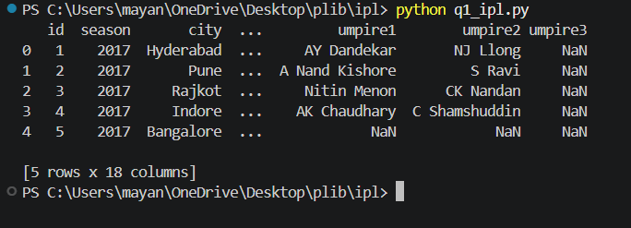

Q2 | Find a small JSON dataset of trending songs (for example, from Spotify's API samples or any open JSON file), and use pd.read_json() to import it into a DataFrame. Display the DataFrame's column names and data types using df.info().
Code | import pandas as pd  df = pd.read_json("songs.json")  df.info()
Output | 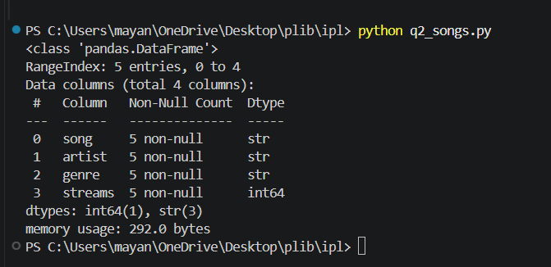

Q3 | You have a TSV (tab-separated values) file containing Zomato restaurant data. Use pd.read_csv() with the correct separator to load the data, and then use df.describe(include='all') to generate summary statistics.<br><br><em><strong>Hint:</strong> The separator for TSV files is '\t'.</em>
Code | import pandas as pd  df = pd.read_csv("zomato.csv")  print(df.head())  print(df.describe(include="all"))
Output | 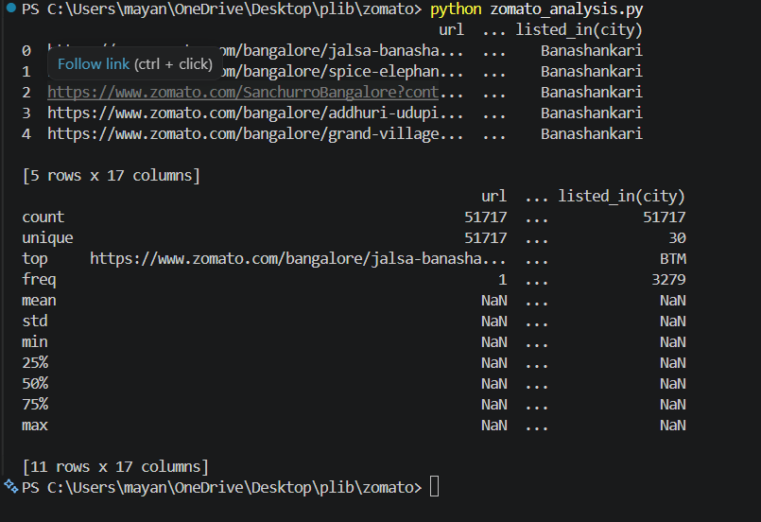

Q4 | Download a large Excel file (at least 10,000 rows) of Flipkart product listings. Use pd.read_excel() with the chunksize parameter to read the file in chunks of 2000 rows, and print the number of rows in each chunk as you iterate.
Code | import pandas as pd  df = pd.read_csv("flipkart_com-ecommerce_sample.csv")  print("Total rows:", len(df))  for start in range(0, len(df), 2000):  chunk = df.iloc[start:start + 2000]  print("Number of rows in this chunk:", len(chunk))
Output | 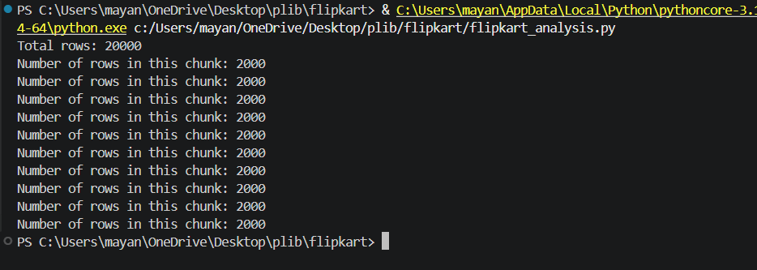

Q5 | Use ChatGPT or Copilot to generate a Python code snippet that reads a semicolon-separated CSV of Paytm transactions, detects missing values, and prints out which columns have nulls. Test the code with a small sample file and fix any errors you encounter.
Code | import pandas as pd  def check_missing_values(file_path):  # Read semicolon-separated CSV  df = pd.read_csv(file_path, sep=';')  print("Preview of data:")  print(df.head(), "\n")  print("Shape (rows, columns):", df.shape, "\n")  # Count missing values per column  null_counts = df.isnull().sum()  # Keep only columns that actually have missing values  columns_with_nulls = null_counts[null_counts > 0]  if columns_with_nulls.empty:  print("No missing values found in any column.")  else:  print("Columns with missing values:")  print(columns_with_nulls)  if __name__ == "__main__":  check_missing_values("sample_paytm.csv")
Output | 